**# COVID-19 AppFinal**

A Website for Latest COVID-19 Information By State and County

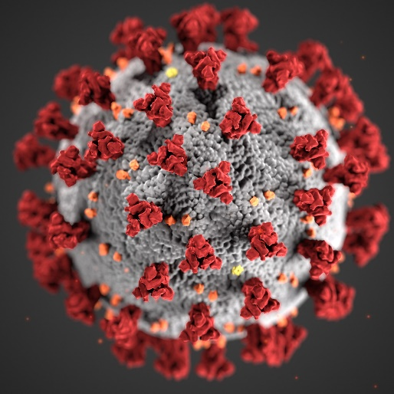

**Overview:**

Our app was designed for the user to find information on local info on COVID-19 stats and information on county health services. The user is also able to view a regularly updated graph showing the current amount of COVID-19 tests given in the U.S, search for COVID-19 related news headlines for a specific country, and use an interactive map displaying infection rates across the entire planet.

**TEAM MEMBERS**

Travis Wright

Contribution: HTML,JS,UI

Github:https://github.com/sivart-wright

Linkedin:https://www.linkedin.com/in/travis-wright-43706b41/

Ricky Paige

Contribution:UI

Github:https://github.com/rickpaige

Zakar

Contribution:

Github:

David Cuero

Contribution: Coronavirus Map App

Github:https://github.com/devouracid

Linkedin:https://www.linkedin.com/in/david-cuero-31385a21/

**COVID-19 Map**

COVID-19 (2019-nCOV / SARS-CoV-2) Coronavirus Map https://ecstatic-noether-5ea480.netlify.app/) is an interactive, animated map for the COVID-19 coronavirus outbreak.

The Mapping application uses an API containing recent Coronavirus statistics and maps out the locations and impact each country is facing.

On the map, it shows a marker for each country with the number of confirmed cases. On top of that, it includes a little popup tooltip that shows more in depth information.

Tech Stack Used

Yarn

Gatsby

Sass

React Helmet

Resolve Src

Leaflet

React Leaflet

Axios-For making requests

API

NovelCOVID API : https://corona.lmao.ninja/v2/countries

Objective: To provide information regarding COVID-19 cases globally and locally.

**COVID-19 Tests Graph and News Headlines:**

(A)-technology I used : 1-html 2-css 3-js 4 js bin library

(B)-why I created ? : user can track the latest news and stay informed

(C)-what business problem it resolve ?: The Lab can use to apply for supply and demand so need to import test kit or anything else more or less than they need